HOW TO COPY MULTIPLE TABLES FROM DATABASE IN A SINGLE PIPELINE ACTIVITY.
https://www.youtube.com/watch?v=KsO2FHQdILs
GET LIST OF TABLES
SQL QUERY
Select databasename.information schema.Tables
Create Look Up Table Data Base where list of tables are available for look up
Create table [dbo].[Look Up Table](
Schema_Name varchar(30) null,
Table_Name varchar(30) null
);
Insert into [dbo].[Look Up Table]([Schema_Name],[Table_Name])
values('dbo','Client'),
('dbo','AccountData'),
('dbo','Transactions'),
('dbo','LoanData');
Select * from dbo.[Look Up Table]
Bring Look up table in warehouse workspace
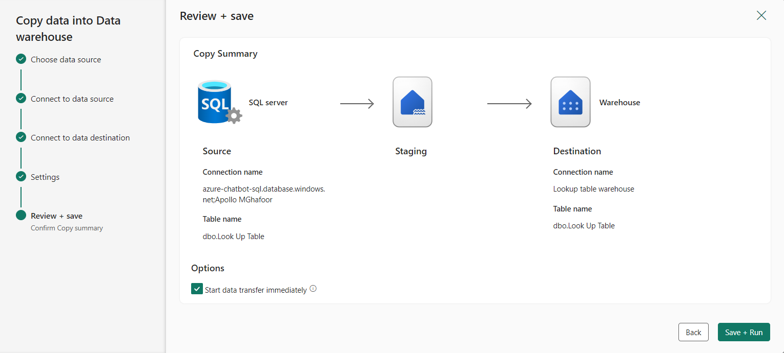

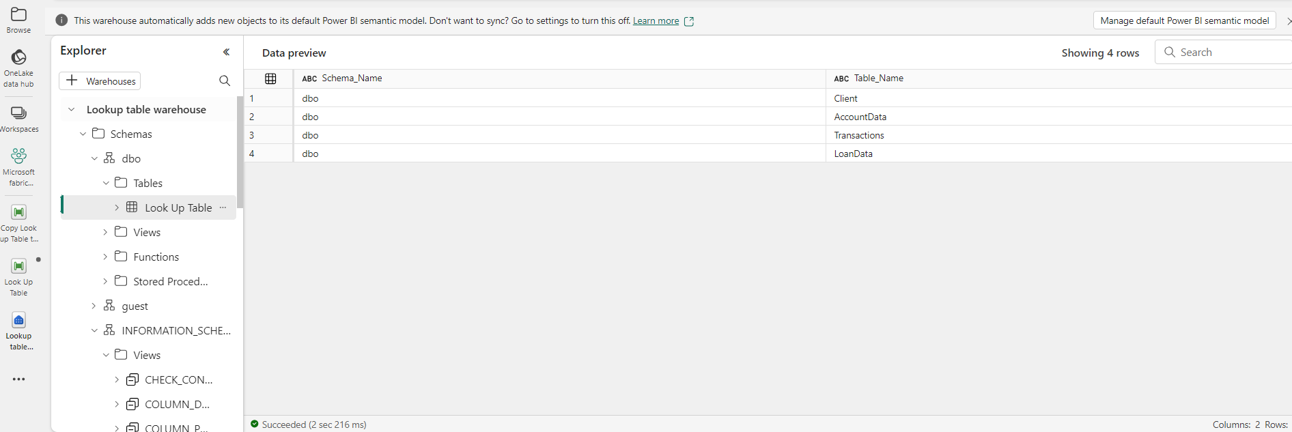
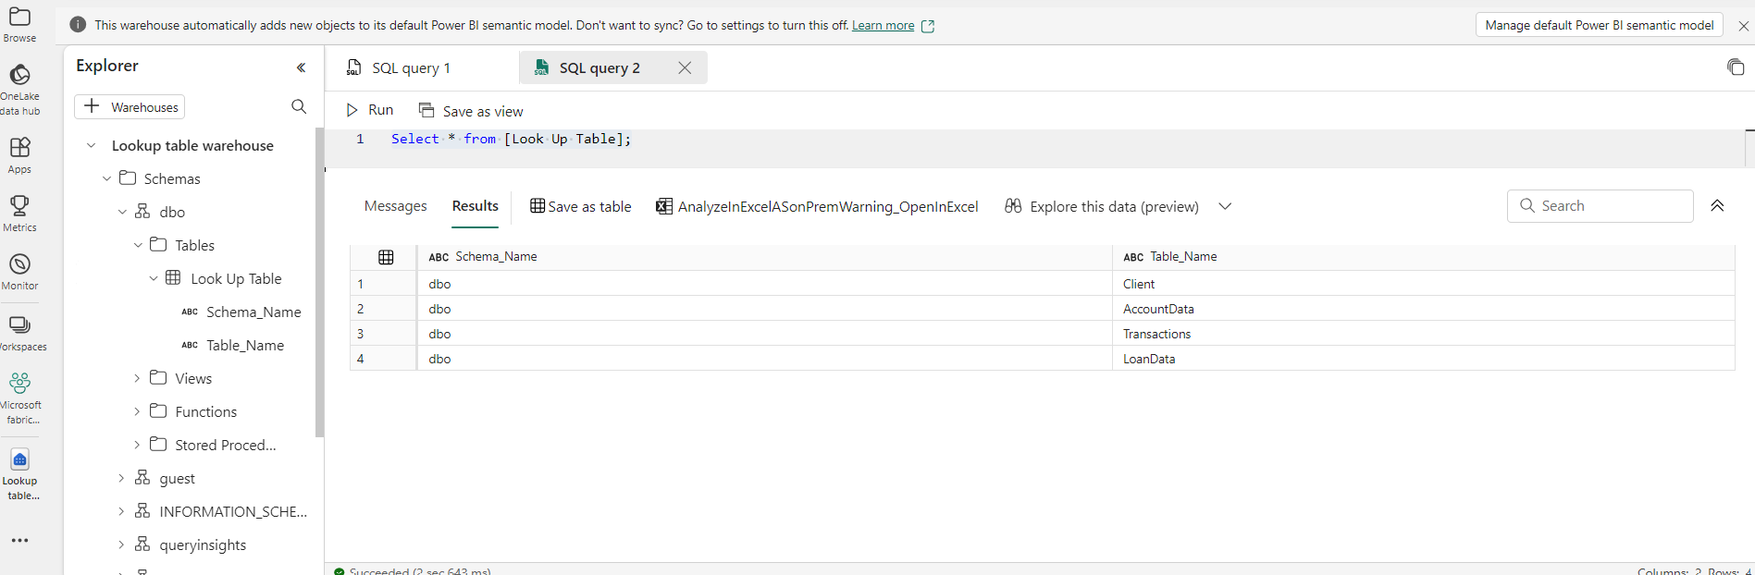
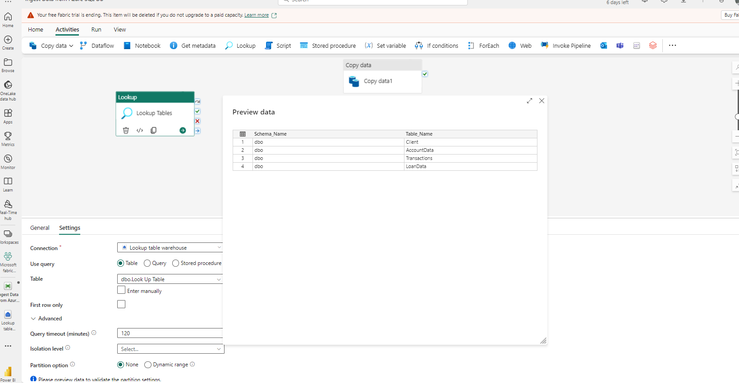
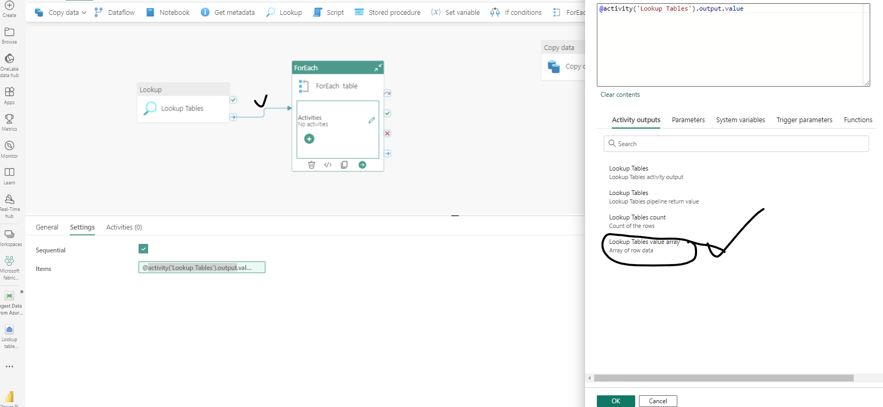
Create two(02) variables
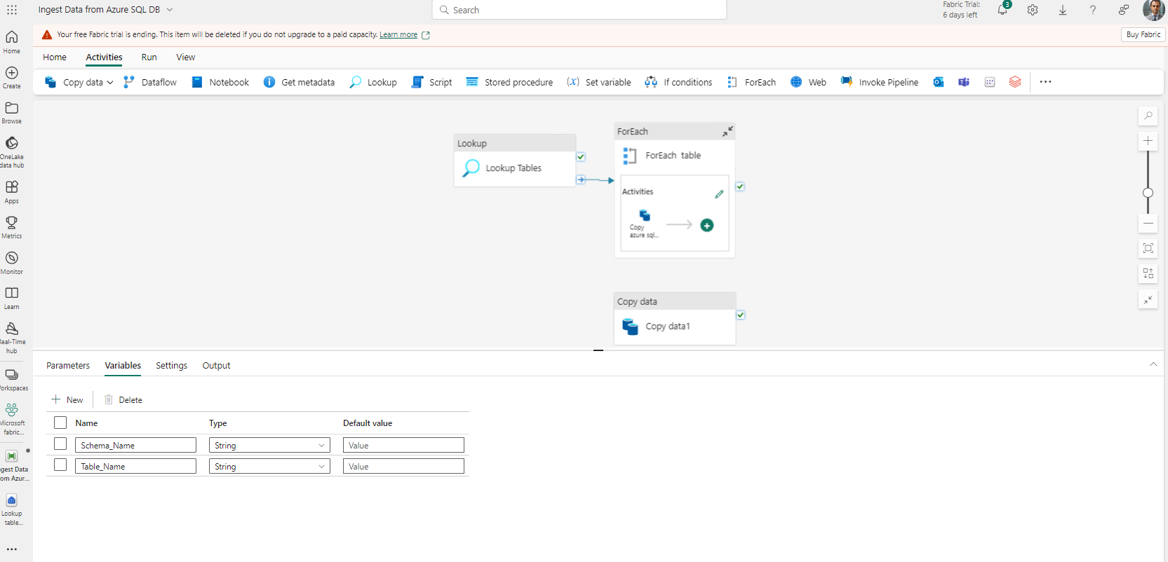

First Variable Set up
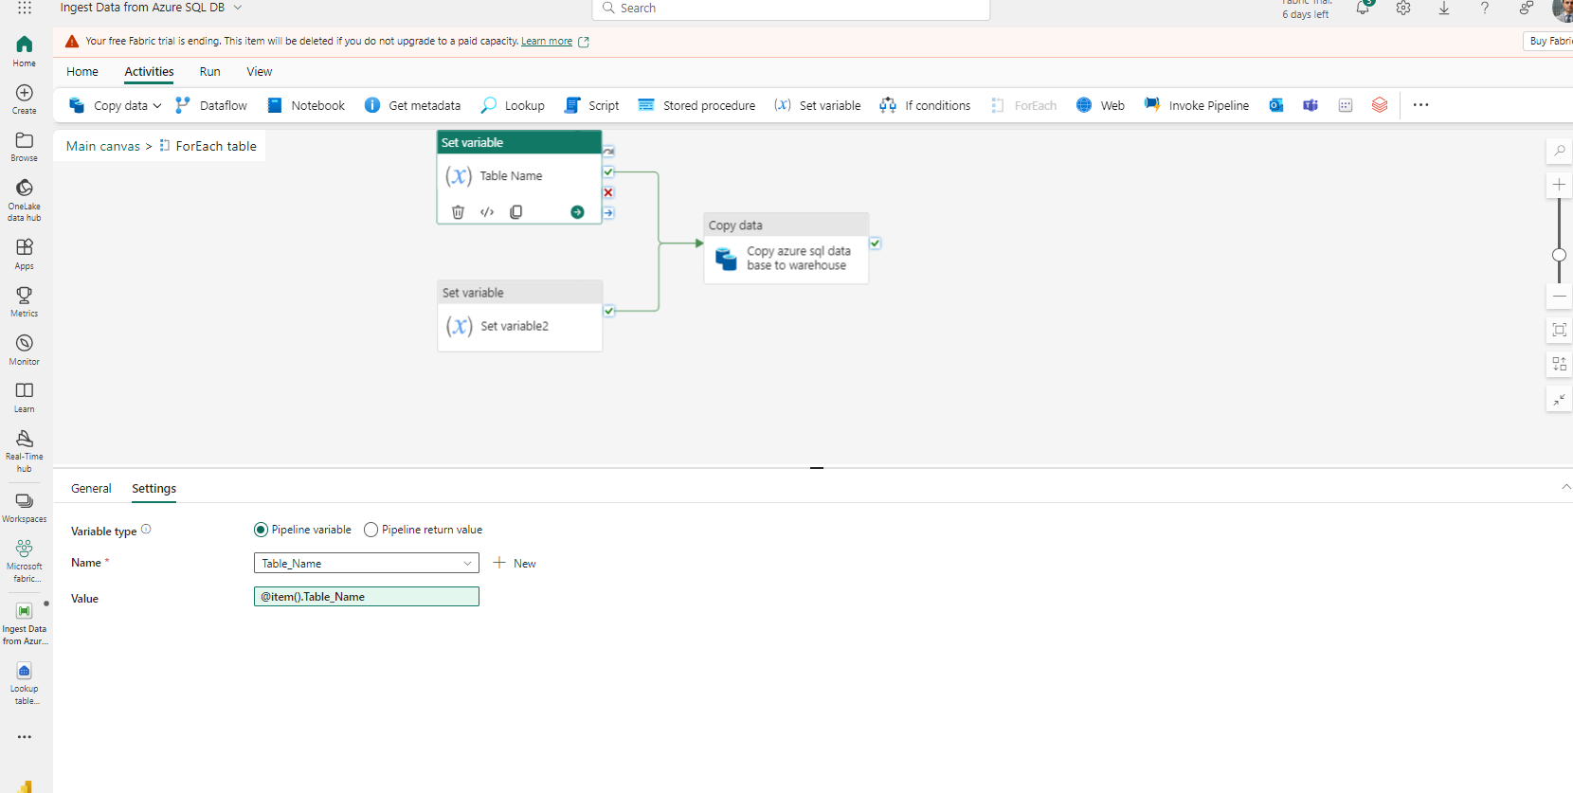
2nd Variable Setup
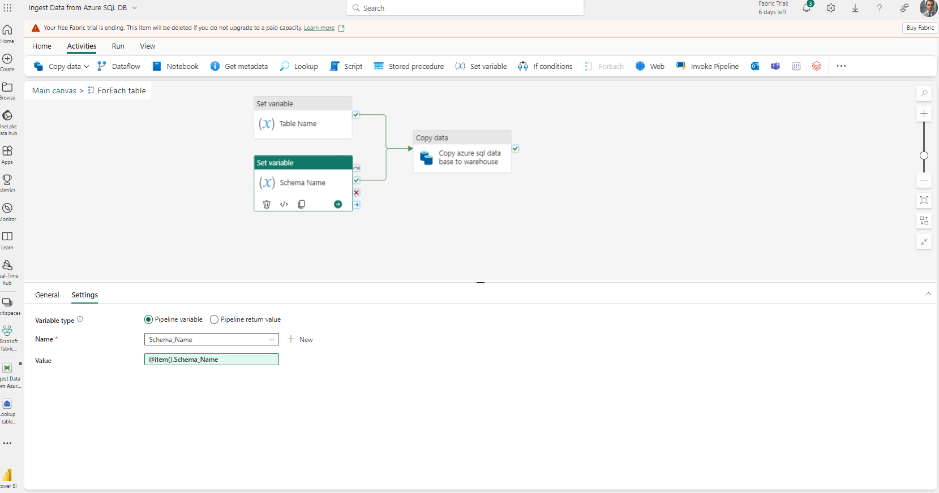

@concat('select * from ',variables('Schema_Name'), '.’ ,variables('Table_Name'))
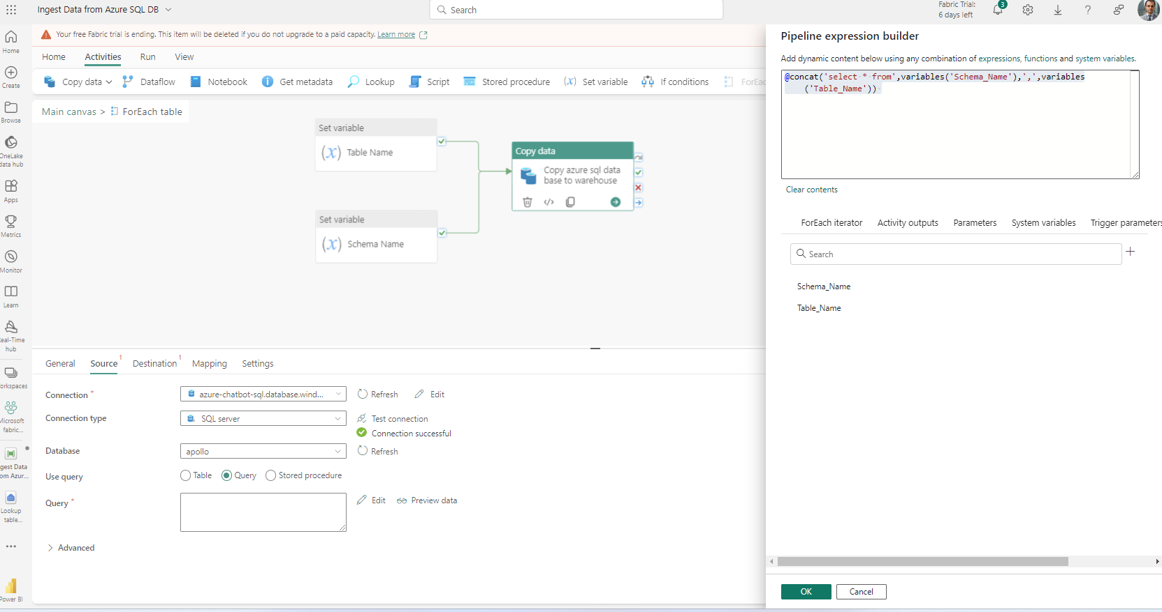

Set Up Destinations in Azure Data Factory.
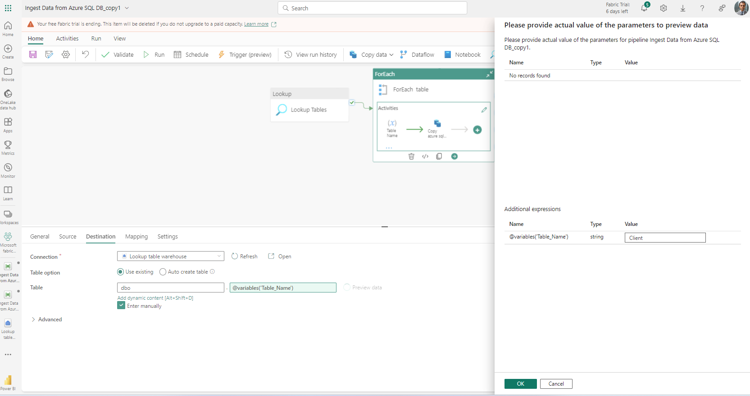

Destinations Step
You need to create a tables in Datawarehouse
create table dbo.AccountData (
AccountNo int not null,
ClientID int not null,
AccountBalance decimal(18,6) not null,
Date date not null)

create table dbo.Transactions (
TransactionsID int not null,
AccountID int not null,
TransactionDate date null,
Amount decimal(18,2) null,
TransactionType varchar(20) null
)

create table dbo.LoanData (
LoanNumber int null,
ClientID VARCHAR(30) null,
LoanType varchar(50) null,
Loan_status varchar(50) null,
LoanDueDate date null,
Original_Loan_Paid_Amount(VARCHAR(50), null,
Loan_Outstanding_Balance(Varchar(50), null,
LoanPaidDate date,null,
Sector varchar(50) null,
Client varchar(50) null
)
When copying Multiple Tables The Source Schema and the destination must be the same.
